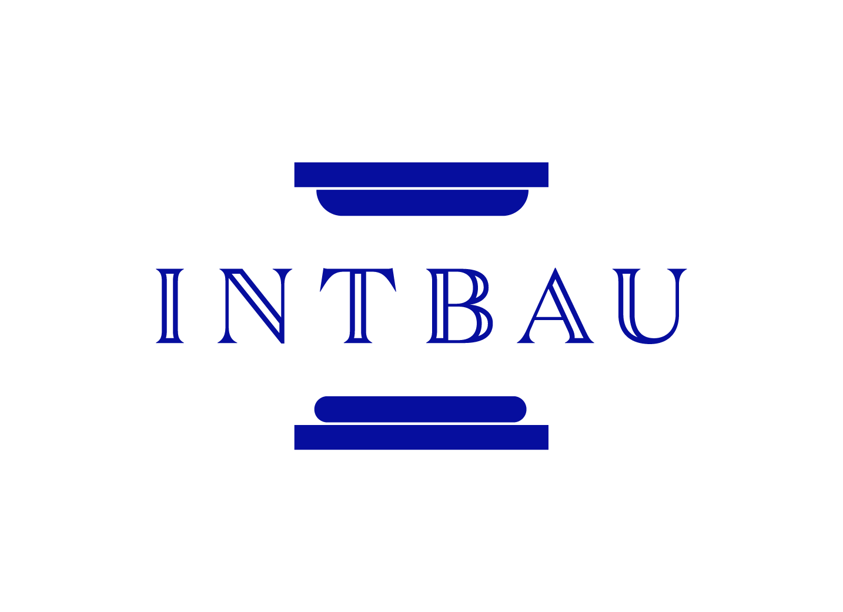

International Network for Traditional Building, Architecture and Urbanism
(INTBAU)

CONSTITUTION
Contents:

- Charter

- General Provisions

- INTBAU Chapters

- INTBAU College of Chapters (ICC)

- Management Team

- Annual General Meeting

- Secretariat

- Honorary Fellows

- INTBAU College of Traditional Practitioners (ICTP)

- INTBAU Young Practitioners (IYP)
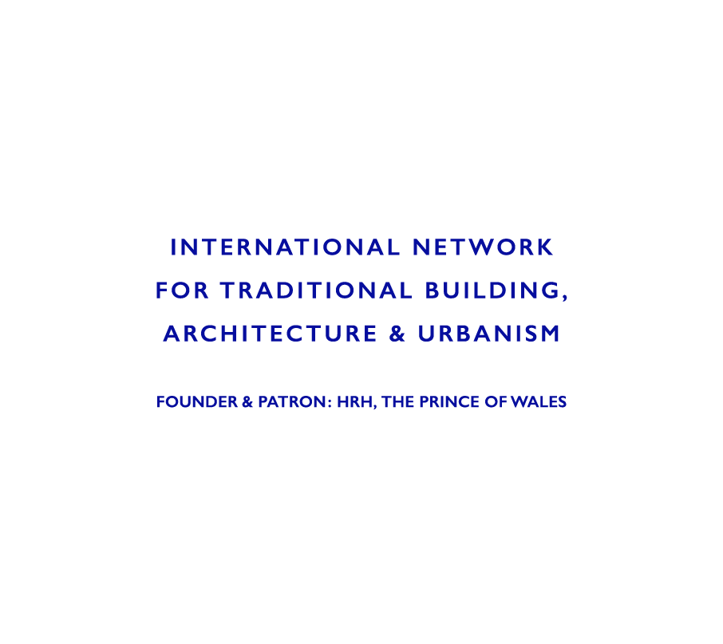
- Membership Structure

- Governing Documents

- Charter
The International Network for Traditional Building, Architecture and Urbanism (INTBAU) is an active network of individuals and institutions dedicated to the creation of humane, harmonious and ecological buildings and places that respect local traditions.
Traditions allow us to recognise the lessons of history, enrich our lives and offer our inheritance to the future. Local, regional and national traditions provide the opportunity for communities to retain their individuality with the advance of globalisation. Through tradition we can preserve our sense of identity and counteract social alienation. All people deserve the freedom to maintain their traditions.
Traditional buildings and places maintain a balance with nature and society that has been developed over many generations. They enhance our quality of life and constitute an authentic and entirely proper reflection of contemporary society. Traditional buildings and places can offer the basis of a profound modernity beyond novelty, and contribute to a better future.
INTBAU offers to bring together those who design, make, maintain, study or enjoy traditional building, architecture and places. We will gain strength, significance and scholarship by association, action and the dissemination of our principles.

- General Provisions

  - All members, committees and employees of the International Network for Traditional Building, Architecture and Urbanism (INTBAU) will accept, publicly acknowledge and at all times act in accordance with the principles and spirit of the Charter. The INTBAU Charter will be made available to members in as wide a range of international languages as possible.

  - INTBAU is an international network that respects and promotes the diversity of tradition and will not at any time adopt policies or undertake activities that promote the exclusive interest of any nation, cultural, religious or linguistic group.

  - INTBAU is legally constituted of its local Chapters, which are chartered under the laws of their respective countries. Each Chapter is entitled to one voting member of the INTBAU College of Chapters (also referred to herein as ICC).

  - All committees will act in accordance with individual committee constitutions.

  - The ICC acts as the Board of INTBAU and is encouraged to register INTBAU as an NGO at the United Nations and other appropriate international organisations.

  - The Patronage of HRH The Prince of Wales applies to INTBAU UK specifically, although HRH is also Patron of the wider INTBAU movement. Whilst this connection to HRH The Prince of Wales as Patron of the whole movement is of enormous importance and should be celebrated, Chapters other than INTBAU UK may not specifically claim the Patronage of HRH. INTBAU Secretariat should be consulted in case of doubt over the correct way to describe this important link between INTBAU and HRH The Prince of Wales.

- INTBAU Chapters

  - INTBAU is an international organisation but its managing constituents are national Chapters. Each Chapter will have its own trustees or organisers. This arrangement will allow for tax benefits to be obtained for donations on a national basis. Funds raised in each country will be collected by each national organisation and used primarily for activities in those countries. Surplus funds will be re-allocated according to priorities set by the ICC, always in accordance with the objectives and national laws of the relevant national charity, society or organisation.

  - INTBAU members who reside in a country that has a duly formed Chapter are automatically members of that Chapter.

  - INTBAU members who reside in a country without a duly formed Chapter remain members of the international association. Such members may at any time elect to form a national Chapter, by polling the other members within that country and seeking a pledge of approval of 50% or more of the members, and thereafter completing a Chapter Agreement. (Note: This provision is not retroactive to existing Chapters). Further governance is at the discretion of the Chapter and its board.

  - Members of a country with a duly recognised Chapter may also form sub-Chapters through the national Chapter, and at its discretion. National Chapters are encouraged but not required to form sub-Chapters. If they so choose, they should assure that sub-Chapters are fairly represented in the decision-making of national Chapters, but the final decision rests with them. Any such sub-Chapters will be represented by the appropriate national Chapter on the ICC.

  - In exceptional cases and at its discretion, the ICC may accept the voluntary formation of more than one national Chapter (such as when a country has very high population and membership). In that case, a clear delineation must be made between the Chapters, and agreed to by the boards of all Chapters that may preexist or be formed and be presented in writing to the ICC.

  - In exceptional cases and at its discretion, the ICC may accept the voluntary merger of several national Chapters into a trans-national Chapter (such as when population or membership is low). In such a case, a single national office must be maintained as a duly authorized non-governmental organisation in one of the countries represented.

  - The idea of Chapters collaborating and planning joint activities is an important INTBAU value. For promoting any activity pertaining to a country where there is no pre-existing INTBAU Chapter, the ICC must make efforts to help initiate another Chapter, and till such time that a Chapter is formed, continue to involve that country's members in the existing INTBAU events.

  - Any INTBAU-related activity or event pertaining to a country where there is a pre-existing INTBAU Chapter has to have the full agreement of the local Chapter head.

  - Chapters can and should collaborate to create international INTBAU events or INTBAU-supported events. Chapters may also pursue joint funding proposals from international funding agencies to develop these joint programs. To facilitate a clear path of communication, the responsibility must lie with the initiator of the event to ensure that the agreement of the local Chapter chair is received before that Chapter's logo and Chapter-specific publicity material is used in any communication related to that event.

- INTBAU College of Chapters (ICC)

  - The ICC constitutes the Board of INTBAU and will govern INTBAU through the establishment of detailed policies. An ICC Chair, Deputy Chair and ICC Secretary will be elected every two years from among the ICC members.

  - Representation on the ICC is by national Chapter, with each nation entitled to form one Chapter with one vote, in accordance with the Chapter Agreement.

  - The ICC will meet at least annually (with one meeting being formally designated as the Annual Meeting of the ICC). Policy, accounts, committee membership, a report on the previous year's activities and proposals for the following year's activities will be presented, discussed and voted on at the Annual Meeting of the ICC.

  - At the request of one or more members of the ICC and with the agreement of the ICC Chair, a Special Meeting of the ICC may be called at any time. At least 6 weeks notice of a Special Meeting of the ICC will be given to all members.

  - The ICC Secretary may arrange postal or e-mail proxy voting two weeks in advance of the Annual or Special ICC Meeting.

  - All members will have one vote. In the event of an equal division, the Chair will have a second and casting vote.

  - A quorum at a meeting will generally be 50% of membership. If there is no quorum, the Secretary will contact all members by e-mail who may, within a period of two weeks, vote on any motion; motions will be carried by a majority of replies received within the two week period.

  - The date and place of the next scheduled meeting will be agreed at least three months in advance, and could potentially occur on a fixed date and annual location each year.

  - All meetings will be in accordance with an agenda, agreed by the Chair. The ICC Secretary will issue the agenda two weeks in advance of a meeting. Members may request entry of an item in the agenda before the issue date.

  - Written minutes will be kept of all ICC meetings but the details of the discussion and minutes will be confidential to the ICC unless it is agreed otherwise on an item-by-item basis.

  - Changes to governance or the Charter of INTBAU or the removal of any member of the ICC may only be made by a vote of 75% of members present at the Annual ICC Meeting (or at a Special ICC Meeting if it is deemed warranted).

- Annual General Meeting

  - There will be an Annual General Meeting to which all INTBAU members will be invited. The time and place of this meeting will be set at least six months in advance by the ICC, in consultation with the staff of the Secretariat.

  - The Annual General Meeting may coincide with the Annual Meeting of the ICC. This meeting may also coincide with an international member conference and/or academic and professional symposia and exchanges.

  - Policy, membership, a report on the previous year's activities and proposals for the following year's activities will be presented and discussed at each Annual General Meeting.

- Management Team

  - The day-to-day management of INTBAU will be by the Chair, Deputy Chair and Secretary. If none of these positions is filled by the ICC representative for the Chapter serving as Secretariat, there will be a fourth corresponding member of the Management Team representing that Chapter.

  - The role of the Management Team is:
- execution of policy as directed by the ICC;
- guiding the management of day-to-day activities of INTBAU with support from the Secretariat.

  - The Management Team will be established by the ICC and elected among members of the ICC at the Annual Meeting of the ICC every two years.

  - The Duties of the Management Team include:
- management of the advancement and reputation of INTBAU;
- organisation of publications and activities;
- appointment of an international Entry Committee drawn from members of the ICC and INTBAU College of Traditional Practitioners (ICTP) to elect new ICTP members in accordance with the highest standards of traditional practice;
- attendance at ICC meetings;
- execution of detailed policy as directed by the ICC;
- day-to-day management of INTBAU with support from the secretariat;
- management of the budget, income and expenditure of INTBAU;
- collaboration with the Secretariat;
- rent or purchase of property;
- receipt of and proper consideration of reports and advice from the Honorary Fellows and any external agencies;
- supervision of all electronic and written communication and in the development of a communication and outreach strategy for INTBAU and assistance and advice to the Chapters in this regard.

  - The Management Team will communicate by e-mail and telephone. Face-to-face meetings will only take place if necessary.

  - The Management Team may at its discretion delegate its activities to sub-committees consisting of either other members of the ICC or volunteer expert INTBAU members for publications, individual events, campaigns or other activities. Sub-committees will report directly to the Management Team and maintain minutes and full records which will be copied to the ICC and may be copied to Honorary Fellows as deemed appropriate by the ICC.

- Secretariat

  - A Secretariat will be selected from among the Chapters. The Chapter serving as Secretariat will manage the international association on behalf of all other Chapters. A Director will be retained by the Secretariat, supported by funding from the international association and chosen with the consent of the ICC. The Secretariat Director should be able to perform networking and champion the cause of INTBAU.

  - INTBAU is an international organisation of federated Chapters that is represented by the Chapter serving as Secretariat. As such, the Secretariat collects dues and allocates them according to the instructions of the ICC or its Management Team. Funds collected by the Secretariat for its own discretional use must be collected according to the agreed funding scheme for all Chapters, or with the review and approval of the ICC or its Management Team.

  - Subject to approval of the Management Team (and the availability of necessary funding), the Secretariat may appoint such support staff as is required to enable it to fulfill its role in developing INTBAU, its outreach activities, and in the development of Chapters and their activities.

  - The Board of the Chapter serving as Secretariat may elect for the Secretariat to be transferred to another Chapter with one year of notice. The ICC may elect to transfer the Secretariat to another Chapter with one year of notice. (Note: Because of the close connection between INTBAU and HRH The Prince of Wales, and HRH’s specific Patronage of INTBAU UK (see above under “2.6 General Provisions”), it is expected that the role of Secretariat will be fulfilled by INTBAU UK and reside in the UK for the foreseeable future. The efficacy of this will be regularly reviewed by the ICC at the Annual Meeting).

- INTBAU Honorary Fellows

  - There will be a group of Honorary Fellows of INTBAU who will support and promote INTBAU.

  - Honorary Fellows comprise eminent practitioners in all academic, professional, practical and artistic fields concerned with building, architecture and urbanism that support the objectives of INTBAU.

  - The role of Honorary Fellows is to:
- add prestige to the reputation of INTBAU;
- support, promote and participate in the activities of INTBAU in accordance with the INTBAU Charter;
- advise the ICC and Management Team on matters of policy, membership and activities.

  - Honorary Fellows are established by the Management Team and elected by invitation of the ICC Chair following recommendation from the ICC, the Management Team, existing Honorary fellows, the Secretariat’s Director or the Members of the INTBAU College of Traditional Practitioners. Such invitation will be selective and recommendations will be confidential. (A vote of a minimum of 66% of the Honorary Fellows may remove any member, subject to the ratification of the ICC).

  - Collective and individual duties of Honorary Fellows include:
- to support, promote and participate in the activities of INTBAU;
- to advise the ICC and Management Team on matters of policy, membership and activities.

  - The Chair of the ICC will be a de-facto member.

  - Secretarial functions will be provided by the Secretariat of INTBAU.

- INTBAU College of Traditional Practitioners (ICTP)

  - The INTBAU College of Traditional Practitioners (ICTP) is a peak international professional body for practitioners in traditional urban design, architecture and the building arts who have produced a sustained output of traditional work of the highest quality over at least five years of practice.

  - Members of ICTP will be limited to practitioners of the highest standard in the academic, professional, artistic, trade, craft and practical activities concerned with building, architecture and urbanism that support the objectives of INTBAU.

  - Entry to the ICTP is subject to quality assessment by a consistent international Entry Committee, drawn from members of the ICTP and the ICC. Application is by form, submission of portfolio, and payment of a non-refundable examination fee. Each applicant is required to submit a body of work of a high standard, created over a period of at least five years.

  - Generally, applications for the ICTP are proposed and seconded by ICTP members, unless nominated by ICC members.

  - Members of the ICTP are automatically considered as Fellows of INTBAU and may use the designation FINTBAU.

  - Members of the ICTP benefit as follows:
- individual website page on the INTBAU website including biography and image gallery;
- certificate of membership;
- wide dissemination of the list of members;
- association with peak international traditional practitioners;
- recommendations for membership as Honorary Fellows;
- invitation to the annual ICTP meeting and/or conference;
- reduced price at INTBAU conferences;
- use of ICTP logo.

- INTBAU Young Practitioners (IYP)

  - Membership of the INTBAU Young Practitioners (IYP) is open to individuals at the beginning of a career in traditional architecture, urban design, or the building arts. Applicants need not have completed the minimum five years of work required of applicants for ICTP membership.

  - Entry to the IYP is subject to quality assessment by a consistent international Entry Committee, drawn from members of the ICTP and the ICC. Application is by form, submission of portfolio, and payment of a non-refundable examination fee.

  - Members of the IYP benefit as follows:
- members may style themselves MIYP;
- space on a dedicated website page including biography and images;
- certificate of membership;
- wide dissemination of the list of members;
- association with peak international traditional practitioners;
- invitation to the annual ICTP meeting and/or conference;
- fast-track application for membership of the ICTP upon completion of five years of practice.

- INTBAU Membership Structure

Member
[open to anyone with an interest in INTBAU’s cause]

Honorary Fellow
[See Section 8 above]

Fellow of INTBAU and member of the College of Traditional Practitioners (ICTP)
[See Section 9 above]

Member of the INTBAU Young Practitioners (IYP)
[See Section 10 above]

Institutional Fellow
[Institutional (e.g. academic – Schools of Architecture, etc) supporters with a particular interest in supporting INTBAU’s work]

Corporate Fellow
[Corporate supporters – potentially with various tiers of entry level on an annual renewal basis]

- Governing Documents

  - Chapter Agreement

  - This Constitution

