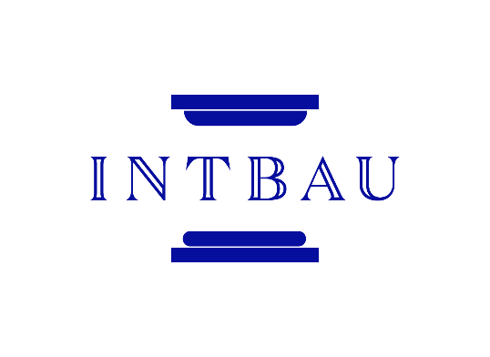  
Trustee Role Description

**Background**

INTBAU is a charity that operates globally, from a base in the UK which operates according to the Standard of Recommended Practice for UK charities. The staff and current trustees of INTBAU are seeking to recruit three new trustees to join the board. All are welcome to apply by submitting

* a cover letter (maximum one page) which outlines the particular strength or skill you would like to offer to INTBAU and
* a CV (maximum two pages)

to [info@intbau.org](mailto:info@intbau.org) by 21 November 2022.

Candidates will be shortlisted by a panel formed of representatives of INTBAU’s chapters, staff, and current trustees.

**Key Tasks**

* Participating in four meetings each year via Zoom.
* Assisting with assigned follow-up actions between meetings.
* Signing off INTBAU’s annual financial accounts.
* Helping the organisation to develop in line with its mission.

The UK Charity Commission summary of key trustee responsibilities can also be read [here](https://www.gov.uk/guidance/charity-trustee-whats-involved).

**Time Commitment**

* Four meetings take place each year, and last for two hours on average. All trustees will be polled to determine the dates and times of meetings.
* Occasional email correspondence on urgent matters takes place between meetings.
* Each trustee is expected to offer their help and support to staff in line with a particular role, background, or skill that they can offer to INTBAU, such as fundraising, education, marketing, or project delivery.
* Trustees can serve a maximum of three three-year terms.

**Liability**

Trustees are tasked with making sure that INTBAU operates to further its mission, within all applicable laws, and making good use of its finances. The key responsibilities of trustees are on the Charity Commission website [here](https://www.gov.uk/guidance/charity-trustee-whats-involved).

INTBAU holds insurance at appropriate levels for trustee indemnity and employer’s liability.

**Specification**

**Essential Skills**

* An understanding of INTBAU and how the charity and its networks operate.
* Work and/or experience which will contribute a particular strength to INTBAU, such as fundraising, education, marketing, or project delivery.
* Ability to work harmoniously with colleagues of all cultures and backgrounds.
* Ability to work with discretion and respect confidentiality in sensitive correspondence.
* Ability to take active part in meetings and correspondence in English, or able to have a colleague or contact assist with translation.

**Highly Preferable Skills**

* Ability to speak languages which are relevant to any of the regions where INTBAU undertakes work.

**Remuneration**

Being an INTBAU trustee does not carry any costs. As such, INTBAU’s trustees are not paid for their time and instead volunteer their services to the charity. In some cases, expenses related to travel or work carried out on behalf of INTBAU can be reimbursed. Participation in quarterly meetings can take place online.

**For more information and to apply, please submit**

* **a cover letter (maximum one page) which outlines the particular strength or skill you would like to offer to INTBAU and**
* **a CV (maximum two pages)**

**to** [**info@intbau.org**](mailto:info@intbau.org) **by 21 November 2022**